EXPERIMENT NO:1

EXPERIMENT NAME: PORT SCANNING TOOLS

OUTPUT:

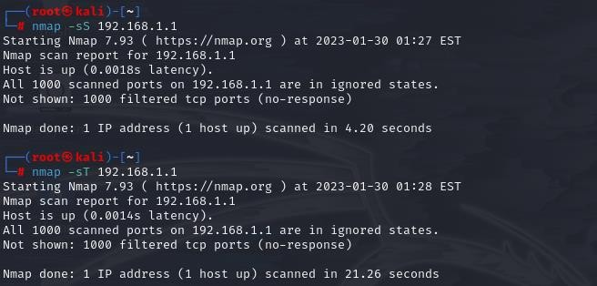

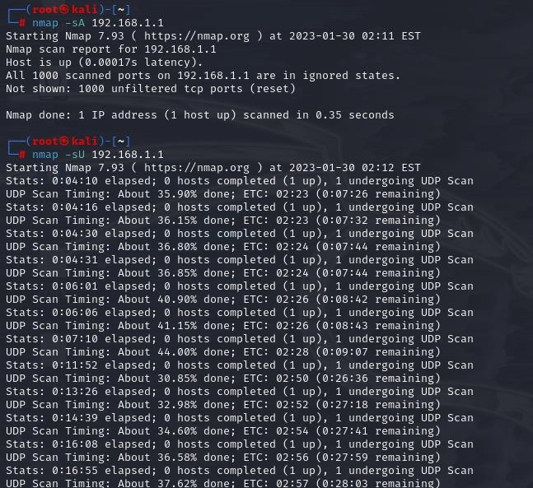

EXPERIMENT NO:2

EXPERIMENT NAME: HOST DISCOVERY

OUTPUT:

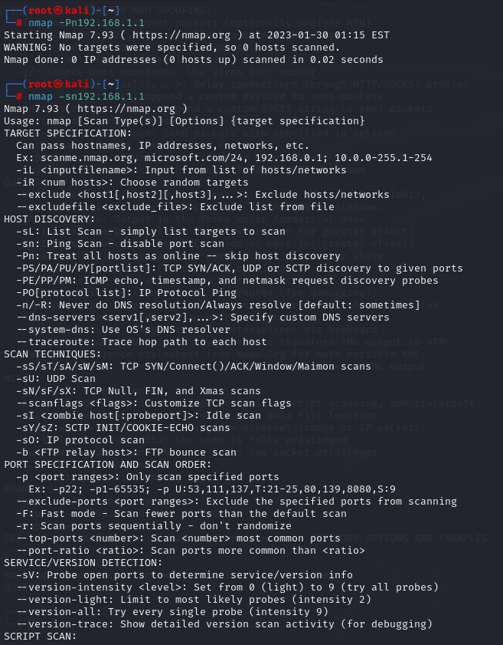

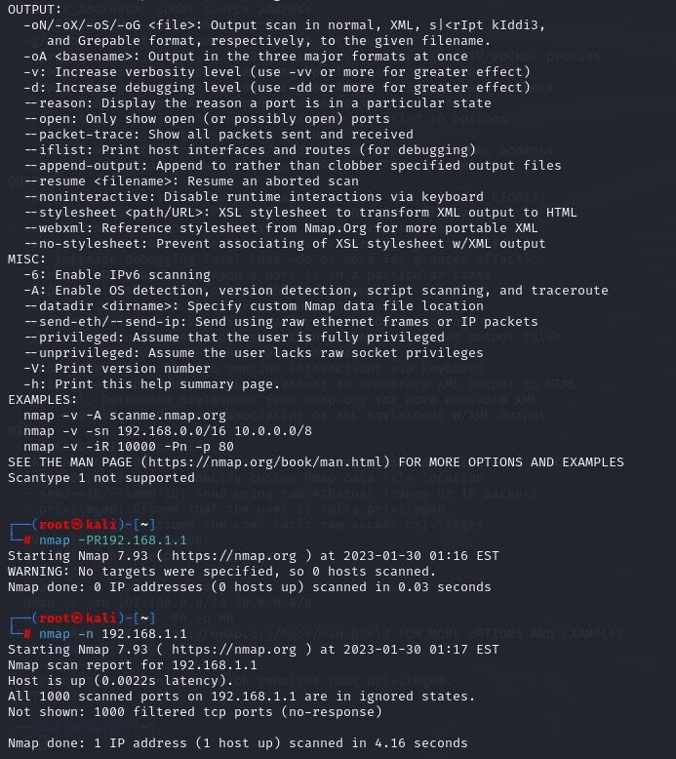

EXPERIMENT NO:3

EXPERIMENT NAME: CRACKING THE PASSWORD USING THE HYDRA

OUTPUT:

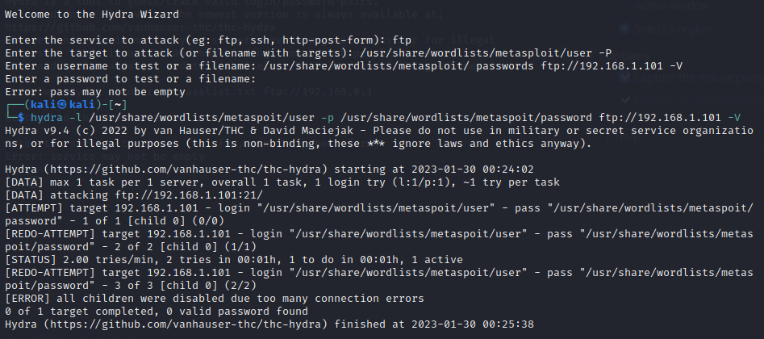

EXPRIMENT NO:4

EXPERIMENT NAME: INFORMATION GATHERING USING THEHARVESTER

OUTPUT:

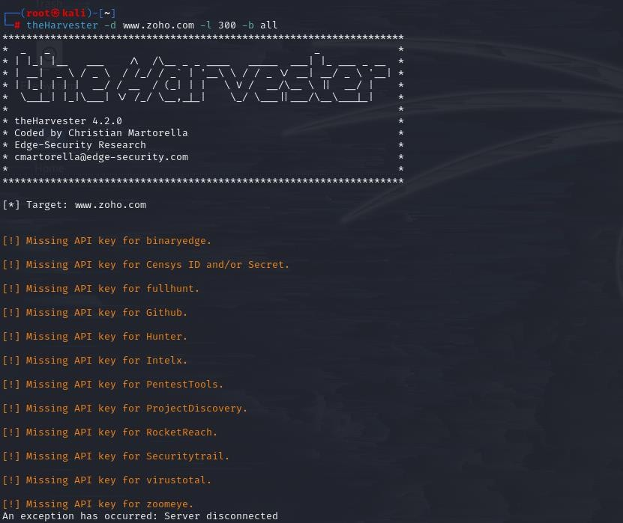

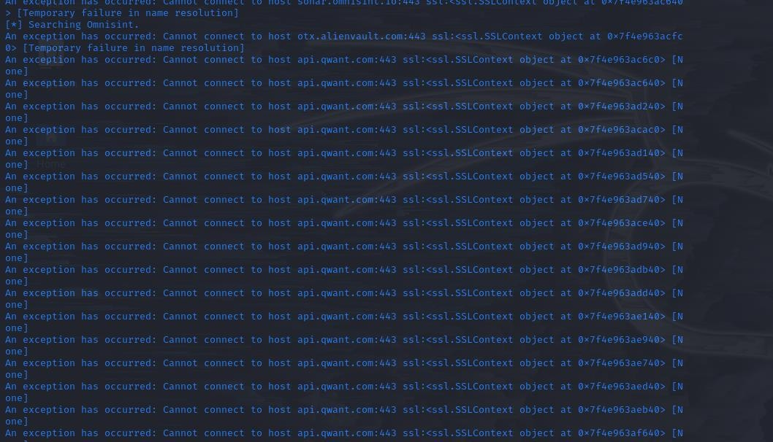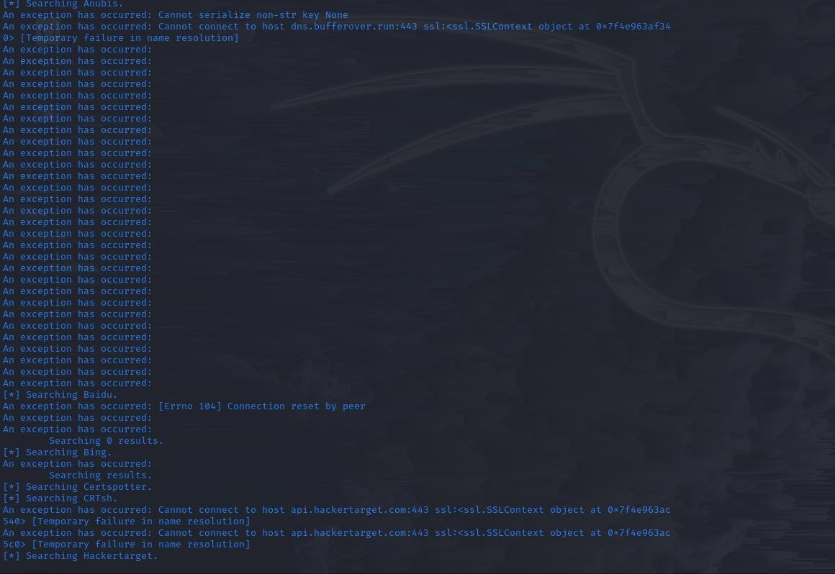

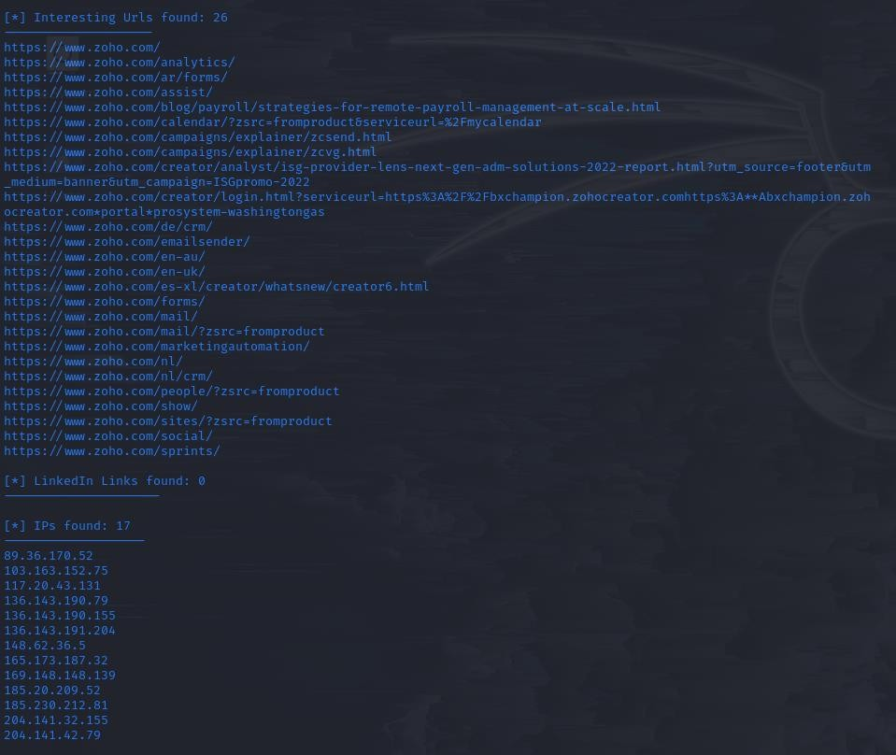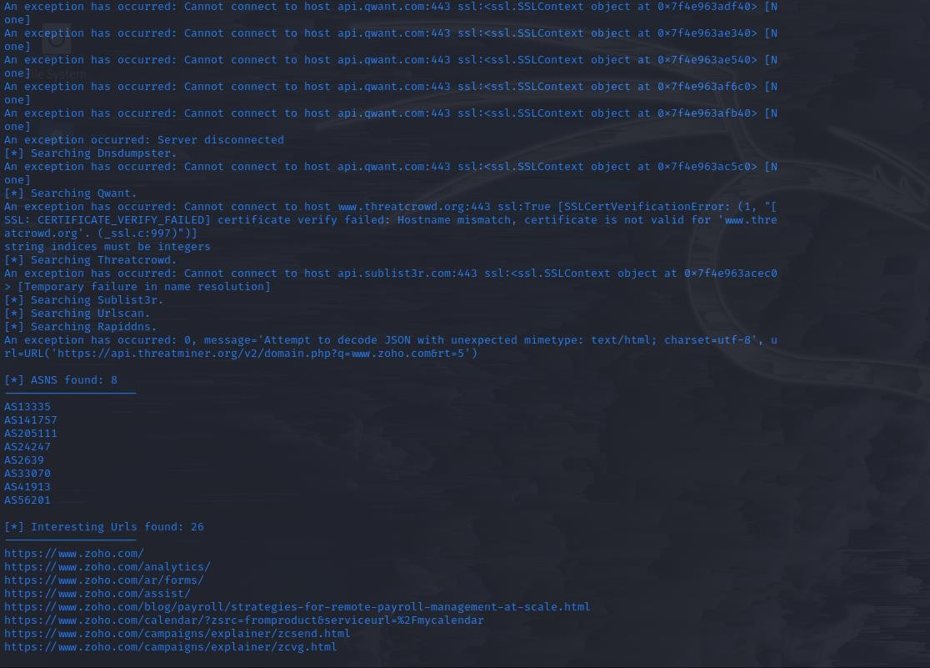

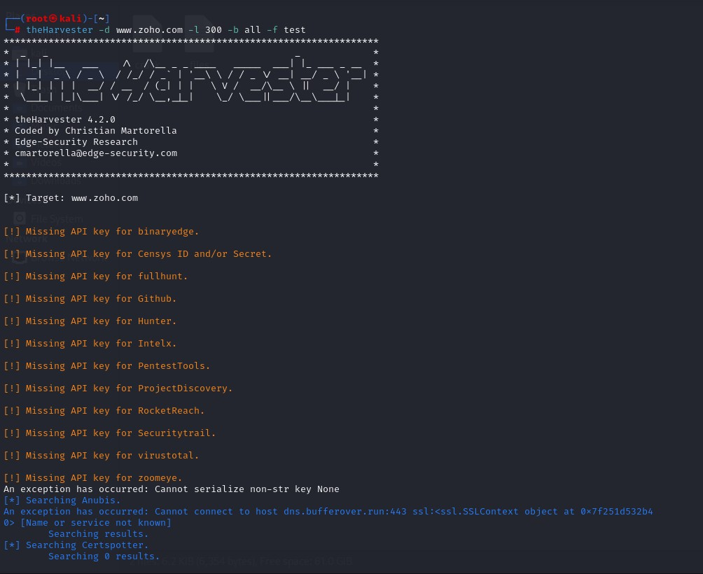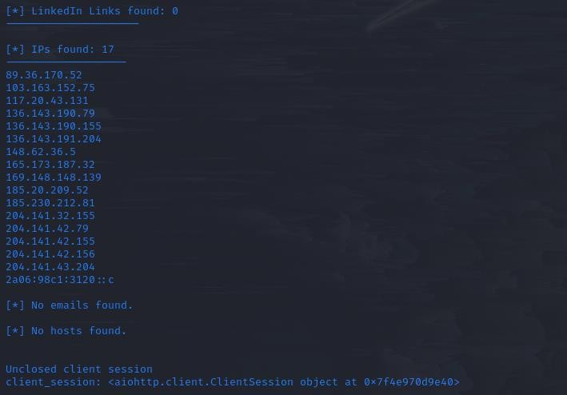

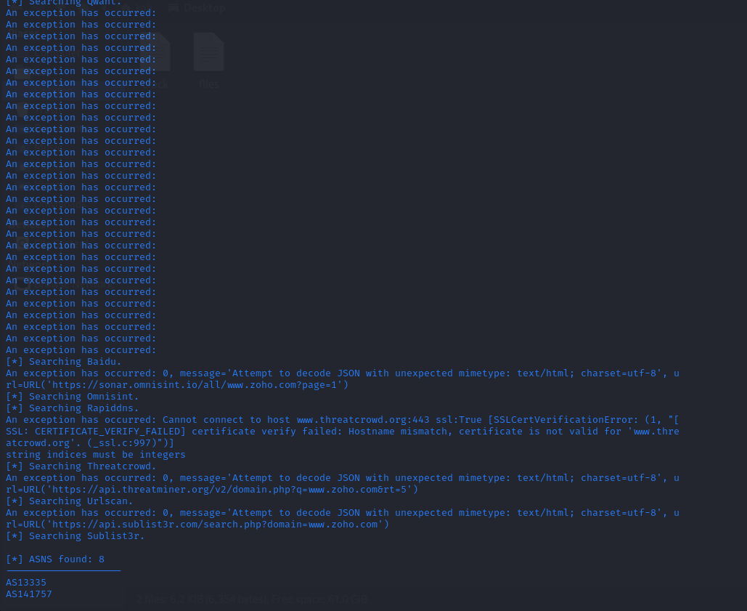



EXPERIMENT NO :5

EXPERIMENT NAME: USE GOOGLE &WHOLE FOR RECONNAISSANCE \

OUTPUT:

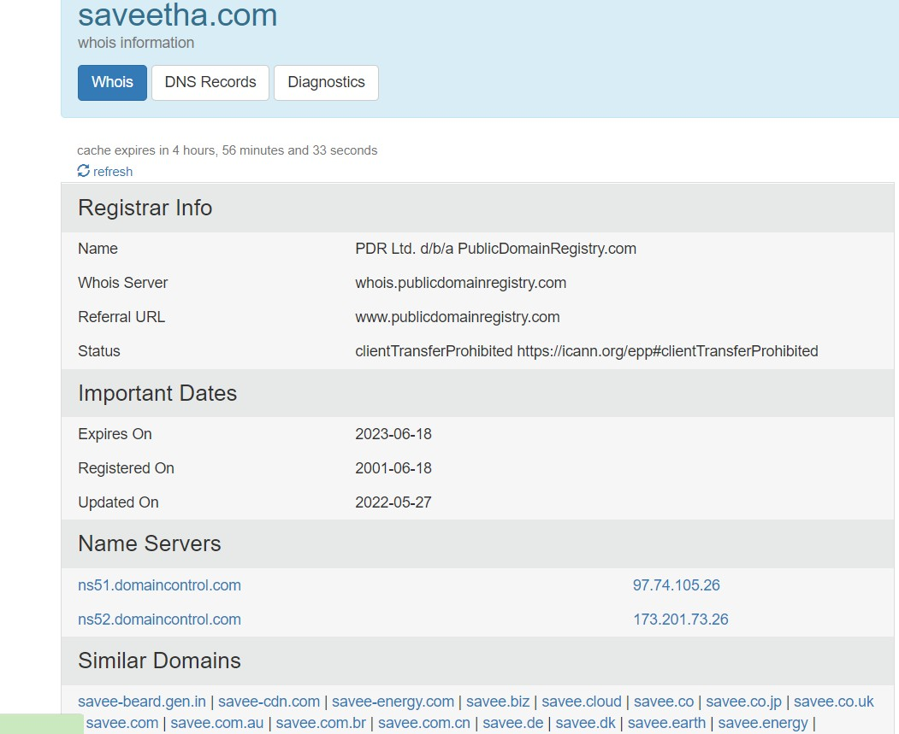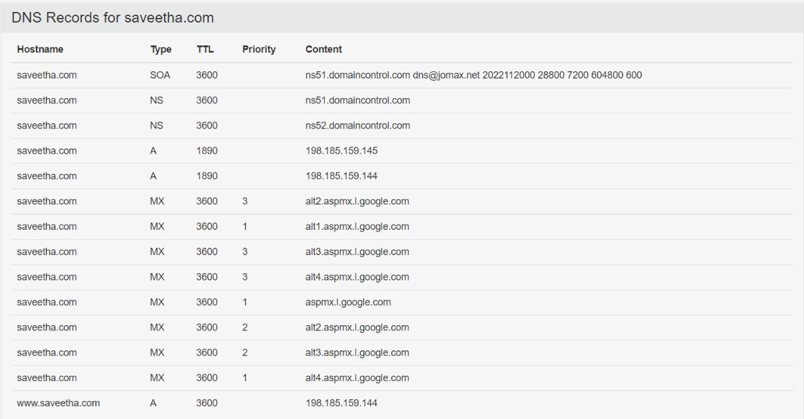

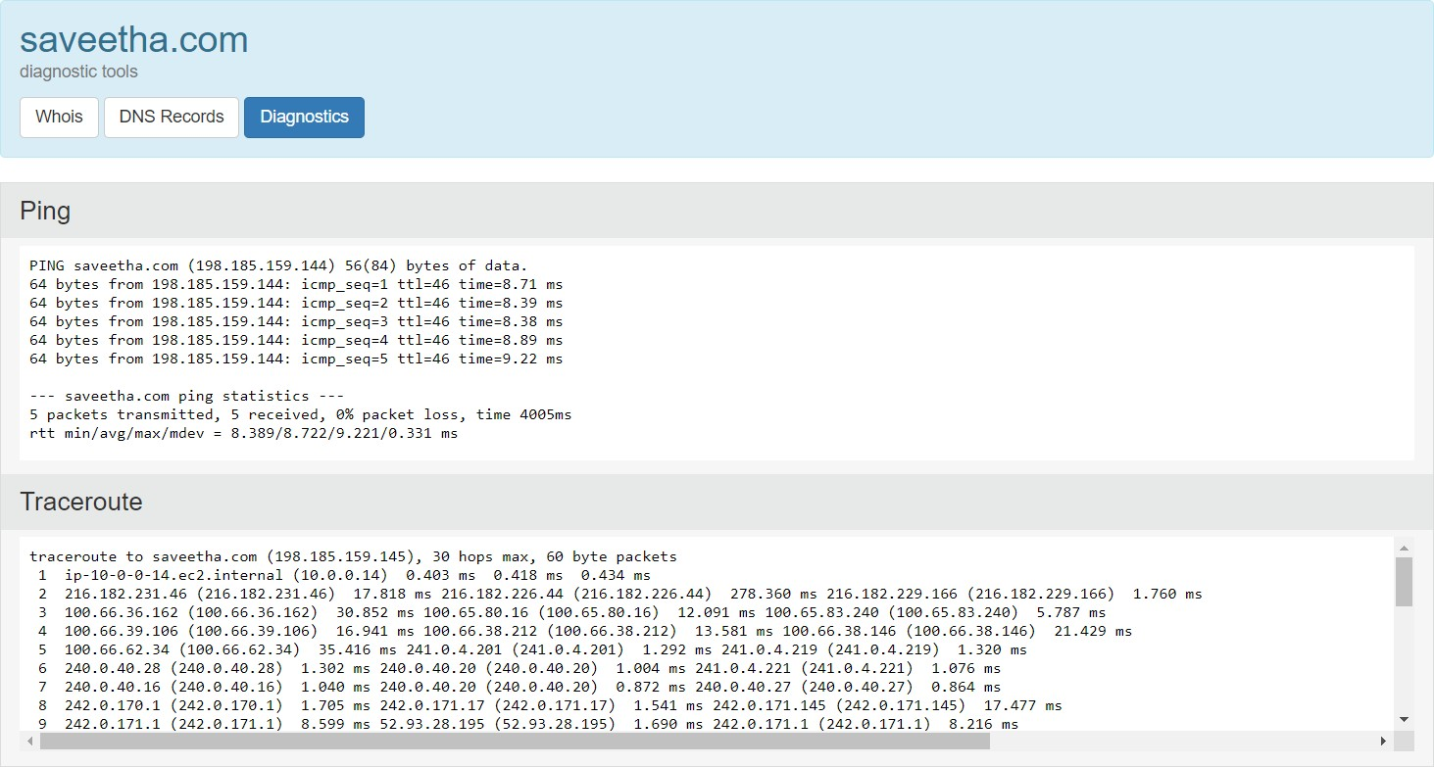

EXPERMENT NO :6

EXPERIMENT NAME:WINDOWS OPERATING SYSTEM COMMANDS EXECUTION TRACEROUTE,PING,IFCONFIG &NETSTAT

OUTPUT:

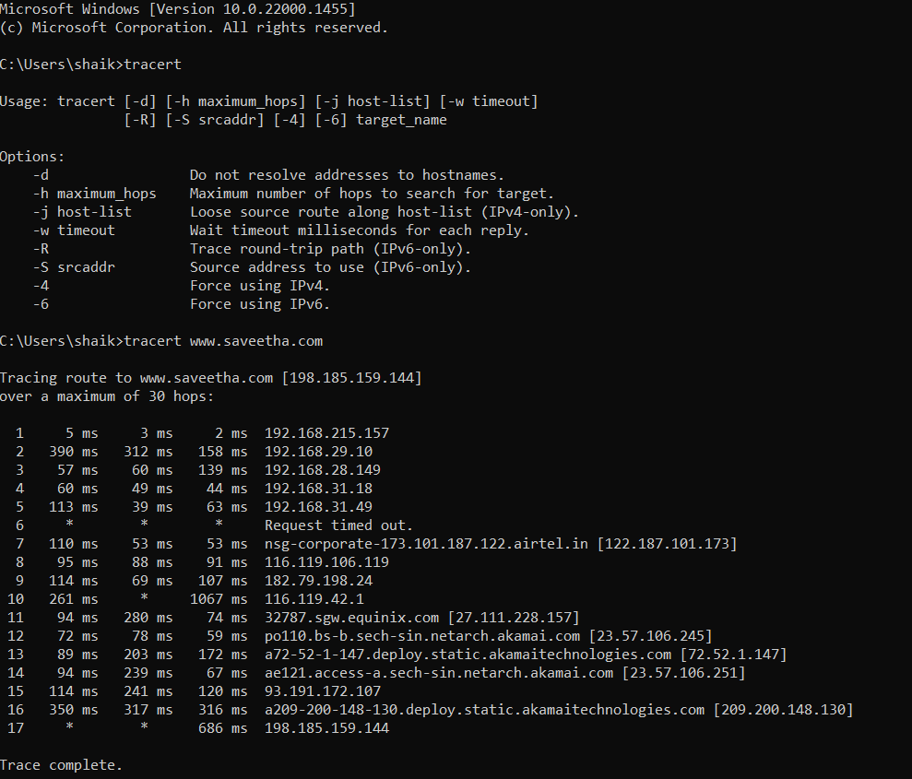

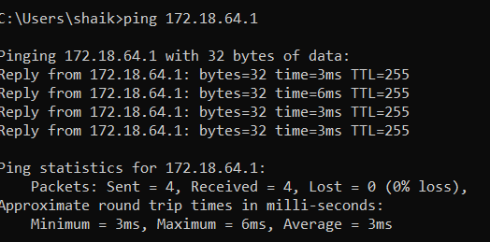

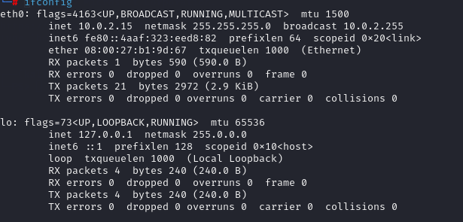

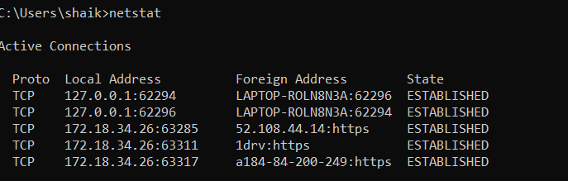

EXPERIMENT NO:7

EXP NAME: VULNERABILITIES ANALYSIS USING CGI SCANNING WITH NIKTO

OUTPUT:

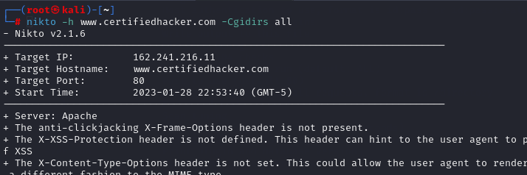

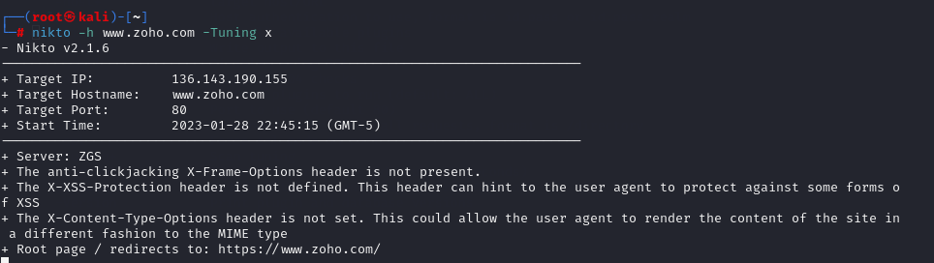

EXPERIMENT NO:8

EXPERIMENT NAME: WIRESHARK SNIFFER FOR NETWORK TRAFFIC &ANALYSE

OUTPUT:

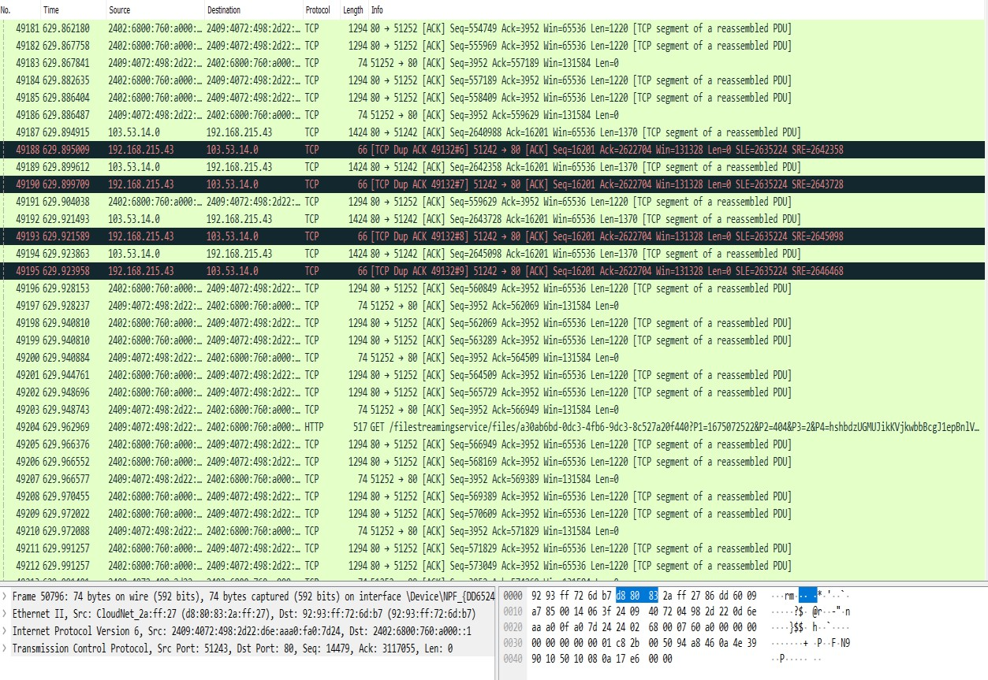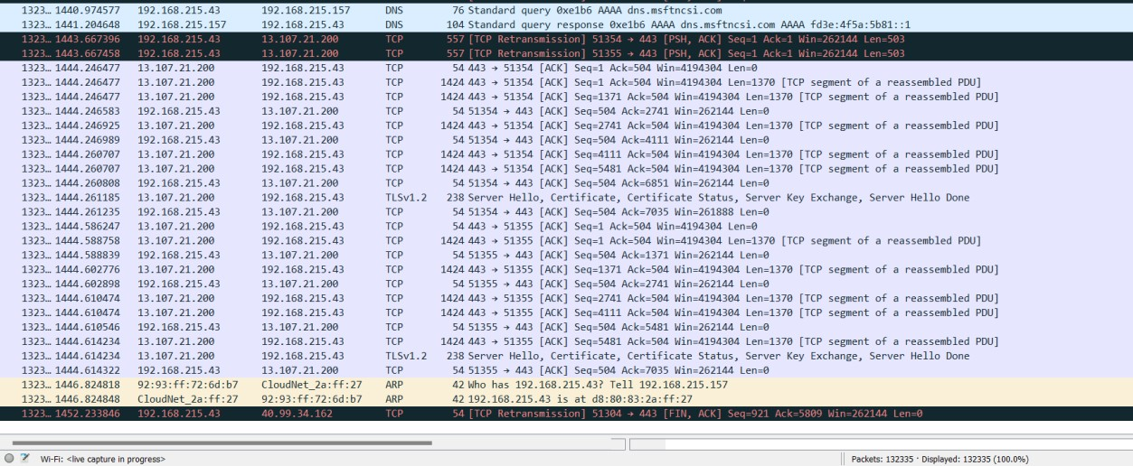

OUTPUT:



EXPERIMENT NO:9

EXPERIMENT NAME:IMPLEMENT THE BOOT SECTOR VIRUS

OUTPUT:

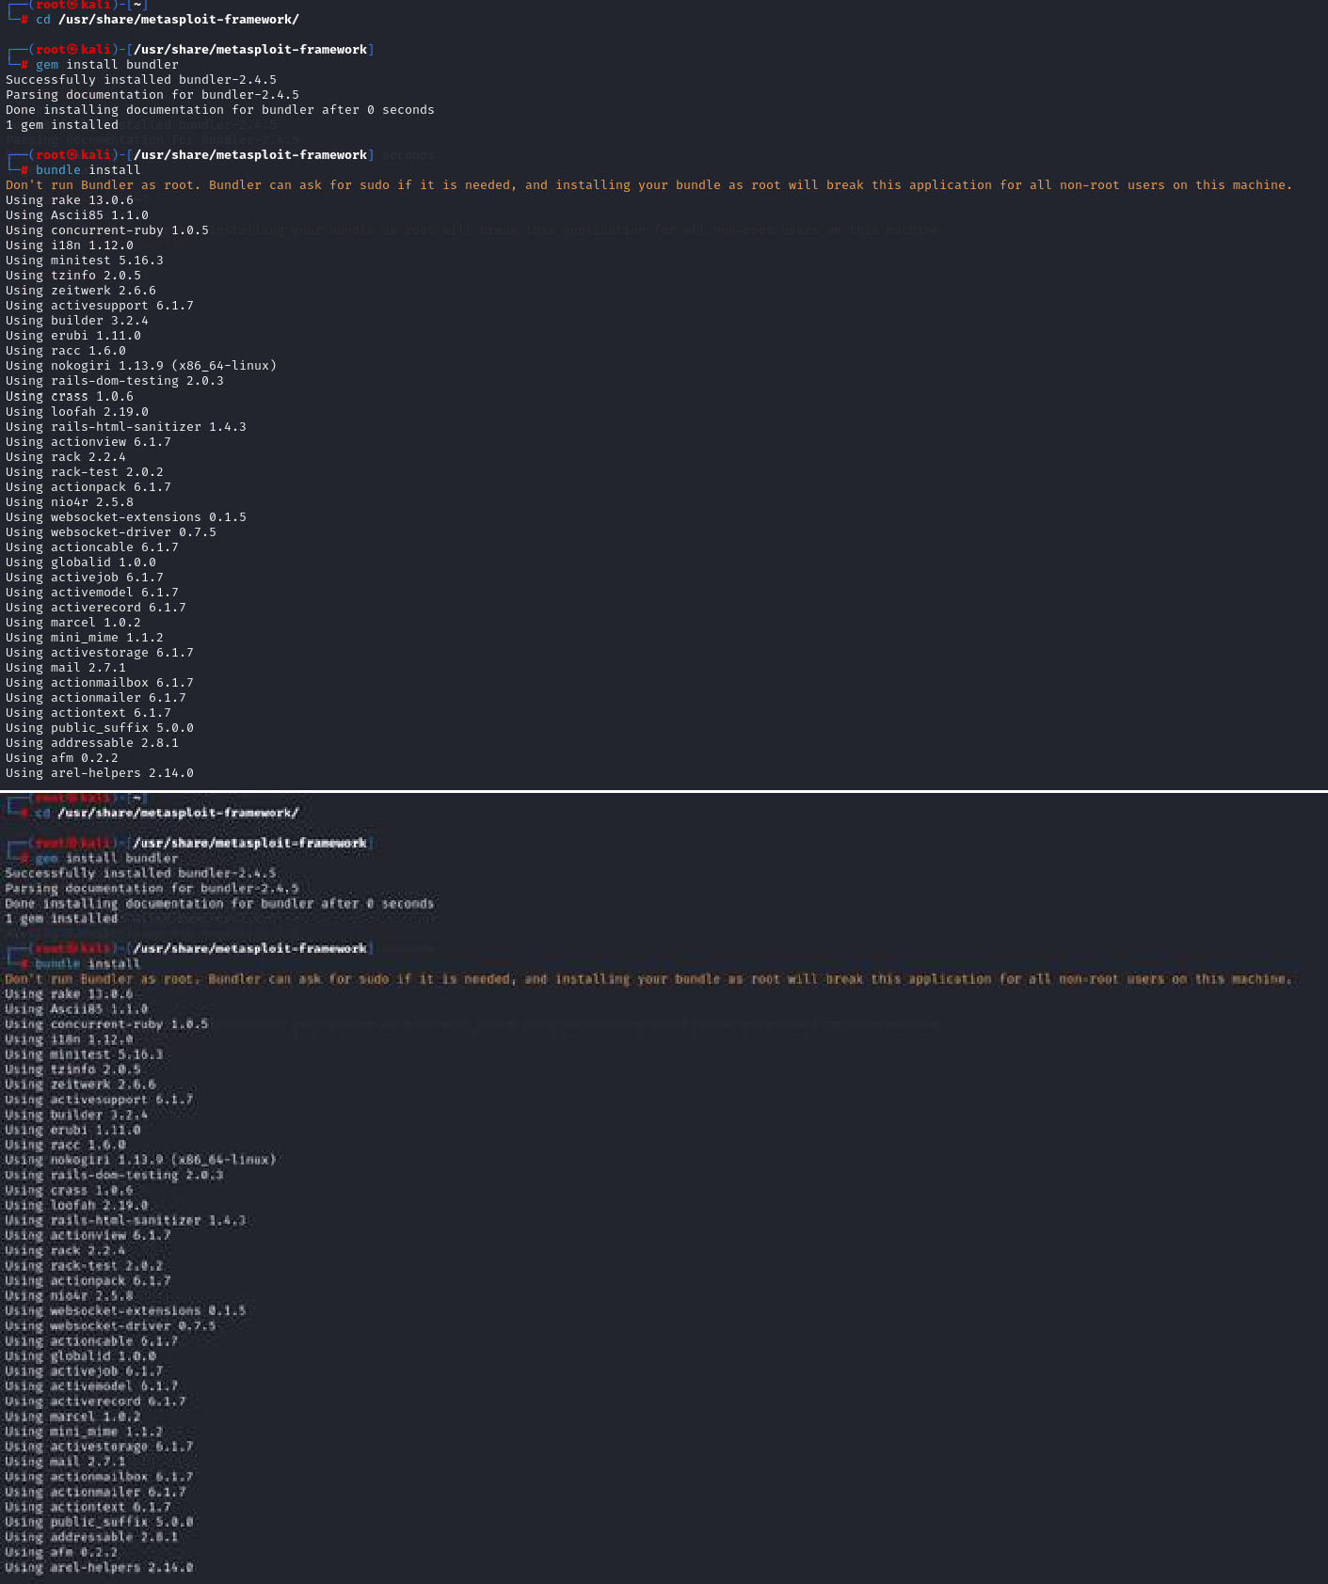

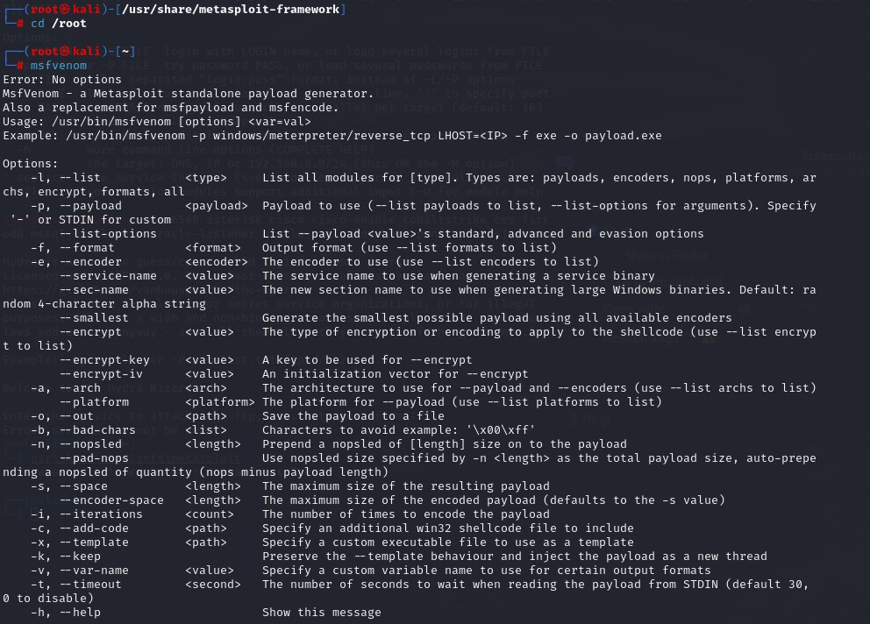

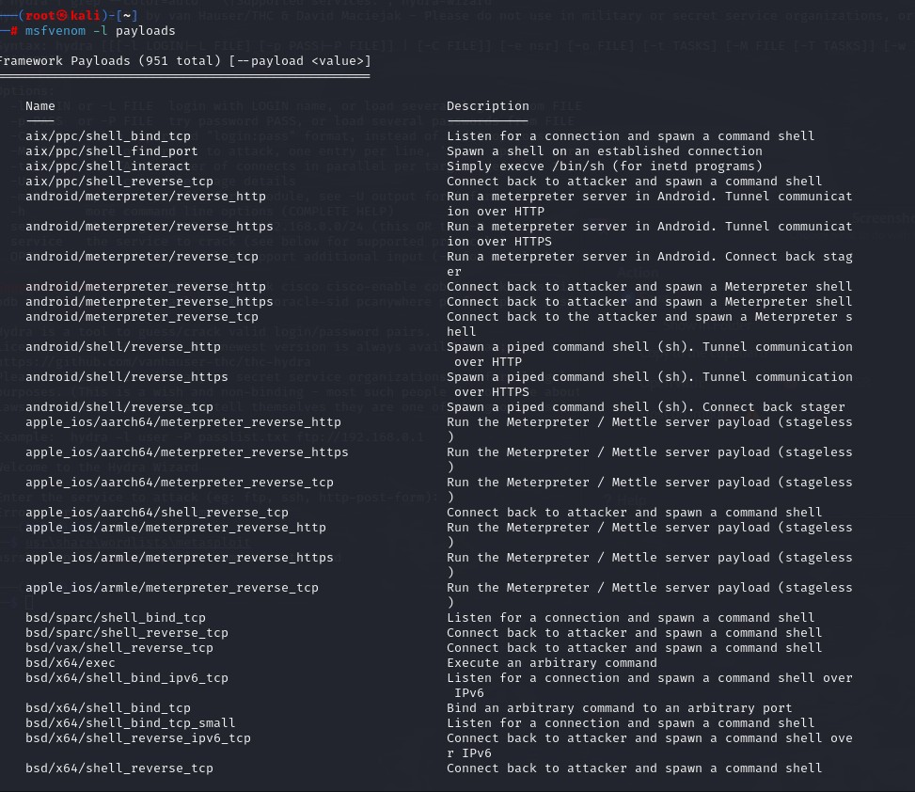

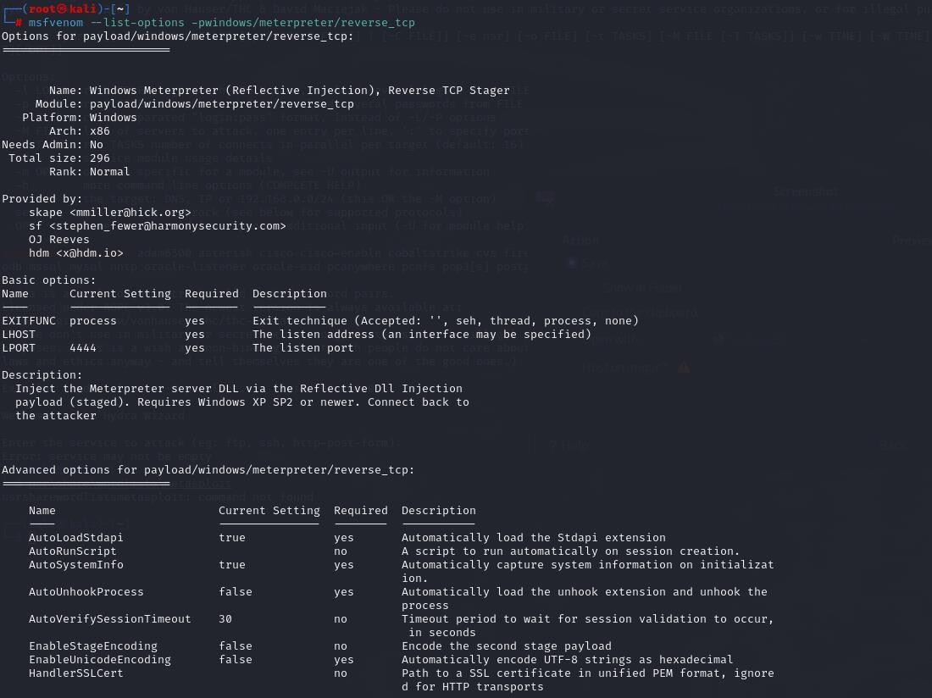

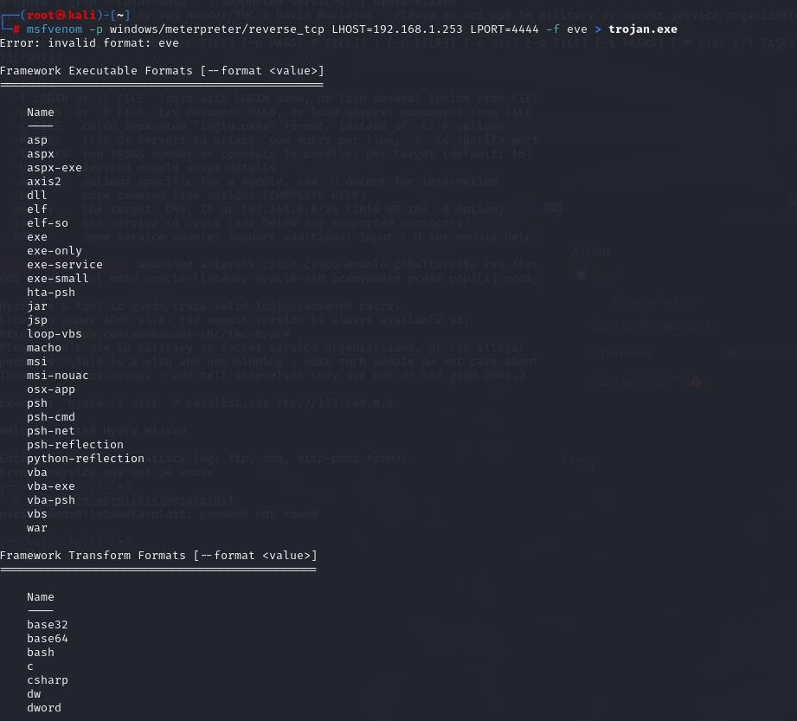

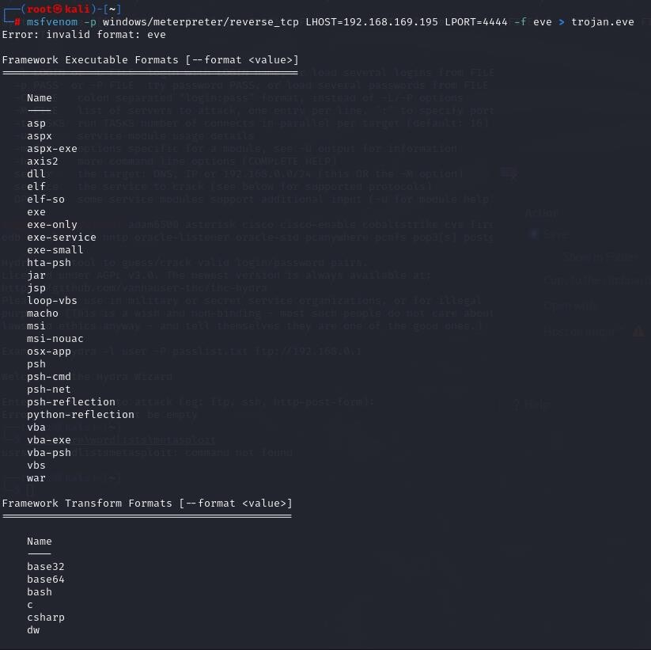

EXPERIMENT NO :10

EXPERIMENT NAME: BATCH FILE EXECUTION

OUTPUT:

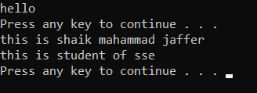

EXPERIMENT NO :11

EXPERIMENT NAME: PACKET ANALYSER TOOL

OUTPUT:

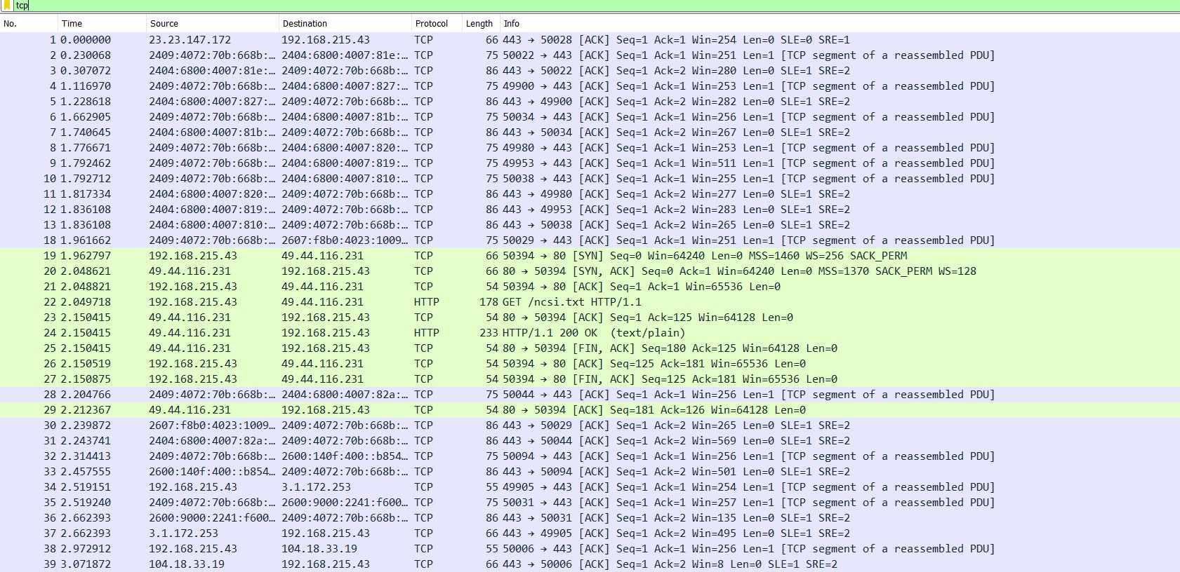

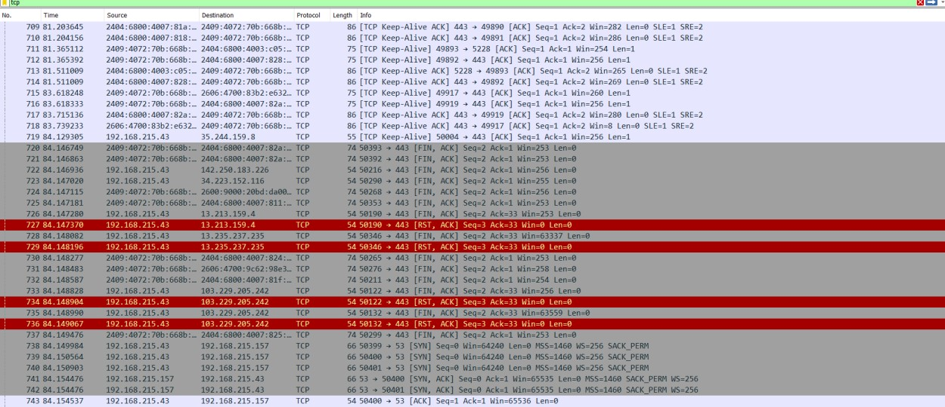

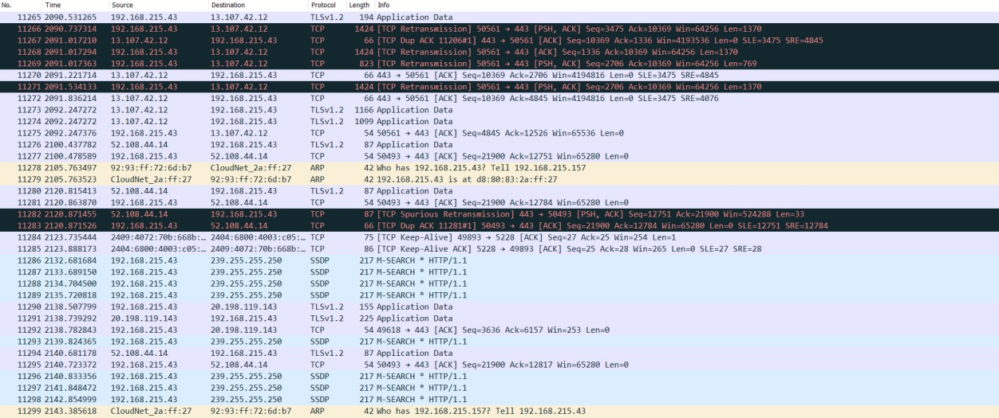

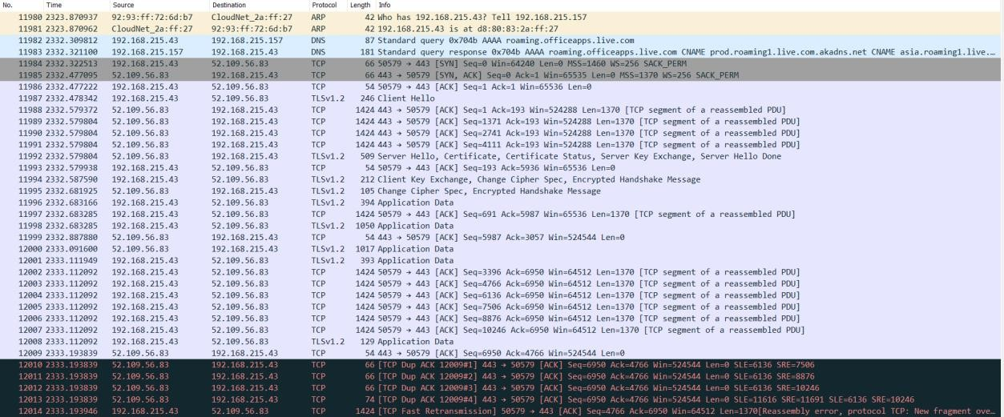



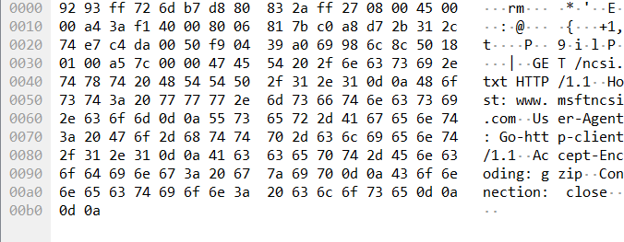

EXPERIMENT NO:12

EXPERIMENT NAME: PORT SCANNING TOOLS

OUTPUT:





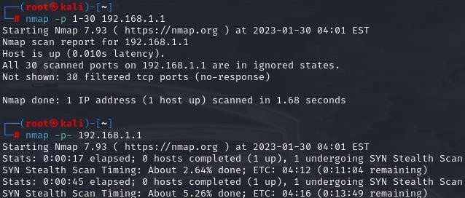

EXPERIMENT NO:13

EXPERIMENT NAME: NMAP TIMING &PERFORMANCE

OUTPUT:

